|  |
| --- |
| ***SafeCase - To Design a Multipurpose Security device for personal and objective security*** |
|  |
| ***A report submitted in partial fulfilment of the***  ***requirement*** ***for the award of degree of***  ***BACHELORS OF ENGINEERING***  ***in***  ***ELECTRONICS AND COMMUNICATION ENGINEERING***  ***SECTION-1 GROUP-B*** |
|  |
| ***Submitted By*** |
| **Devesh Sehgal : 19BEC1082**  **Pankaj Kumari : 19BEC1080**  **Sushant Kumar : 19BEC1078** |
|  |
| ***under the guidance of***  ***Mr. Sukhpreet Singh,***  ***Harbinder Singh*** |
|  |
| ***Electronics and Communication Engineering*** |
| **Electronics and Communication Engineering**  **UIE, Chandigarh University** |

**Table of Contents**

Acknowledgement i

Abstract ii

List of Figures iii

List of Tablesiv

**Chapter** **1.** **Introduction** **1-3**

1.1 1

1.2 2

**Chapter** **2.** **Problem Identification** **4-5**

2.1 Problem in Existing model 4

2.2 Possible Solution 5

**Chapter 3. Design Flow 6-13**

3.1 Flow Chart 8

3.2 Software Required 10

3.3 Hardware Required 12

**Chapter 4.** **Best Possible Design** **14-18**

4.1 14

4.2 15

4.3 17

**Chapter 5. Simulation and Outcome……………………………………19-24**

**Chapter 6. Conclusion and Future Scope………………………….…25-26**

**References** **27-28**

**Cost Analysis ………………………………………………………………....29**

**ECE Archives Project Submission Form…………………………………30**

**Acknowledgment**

I really appreciate that I have such an opportunity to express my great gratitude and respect to people who helped me when I prepared my BE project. Without their supports and encouragements I cannot go so far.

It is difficult to overstate my greatest gratitude to my project mentor **Mr.** **Sukhpreet Singh, Harbinder Singh**, Assistant Professor, and ECE Department. First, I would like to thank him for their patient guiding and inspiring throughout my study period. Secondly, I highly appreciate their encouragement and support in my project work, which helped me build confidence and courage to overcome difficulties. Finally, I am grateful for their great insight and suggestions and sharing so much time in project completion. I would have been lost without their support.

I am as ever, truly and deeply indebted to Prof. (Dr.) S. S. Sehgal, Executive Director, Prof. (Dr.) Nikhlesh Kumar Sharma, Director Engineering and Prof. (Dr.) Paras Chawla, Head of ECE Department for their great supports at every stage of my academic life, and longed to see this achievement come true.

**Abstract**

A small Case/Box with the objective for Multipurpose Security for personal and remote usage. Basically, it would be a very compact and multipurpose device which can be utilized in various ways with main objective to save lives consisting of GSM and GPRS integrated with motion controlled SOS feature. Usage of this device would be heavily focused for people in extreme need for saving and females to keep themselves safe and secure at crucial times.

Nowadays, people are very concerned towards their secret things, so this device will send you a location and a private message, if someone touches your box.

It can also be used as a home security purposes. We can attach it to the main door or windows, when you are outside. If someone tries to open the window or door house, this device will provide you a message that someone tries to open it. So you can complaint or you can reach at time.

**List of Figures**

Figure 1.1: Title of Figure 1.1 9

Figure 1.2: Title of Figure 1.2 9

Figure 2.1: Title of Figure 2.1. 10

**List of Tables**

Table 1.1: Title of Table 1.1 9

Table 1.2: Title of Table 1.2 9

Table 2.1: Title of Table 2.1. 10

# Chapter 1

**Introduction**

A small Case/Box with the objective for Multipurpose Security for personal and remote usage. Basically, it would be a very compact and multipurpose device which can be utilized in various ways with main objective to save lives consisting of GSM and GPRS integrated with motion controlled SOS feature. Usage of this device would be heavily focused for people in extreme need for saving and females to keep themselves safe and secure at crucial times.

Nowadays, people are very concerned towards their secret things, so this device will send you a location and a private message, if someone touches your box.

It can also be used as a home security purposes. We can attach it to the main door or windows, when you are outside. If someone tries to open the window or door house, this device will provide you a message that someone tries to open it. So you can complaint or you can reach at time.

We will use single button feature to access these operations. Anyone can operate this by just clicking the button number of time according to their need.

* By pressing the button **once**, we can access the device for People Safety. By operating this, our device will send location to their relatives and concerned authorities.
* By pressing the button **twice**, the device will work on search and rescue operation in which device provides both location and private message.
* By pressing the button **thrice**, the device can be used as home security purposes and protecting secret things in which all the three features of device will work at same time i.e. sending location, provide private message and thief alerting buzzer.

**Chapter 2**

**Problem Identification**

**2.1 Problems and Drawbacks in Existing Product/ Process**

**2.2 Possible Solution**

**Chapter 3**

**Design Flow and Tools**

A rough diagram can be drawn out of the following circuit diagram for now.

From Following Circuit we can see the different sensors and equipments used such as:

First a Button to select selected mode from three modes of actions, While the Atmega328P acts as the brain of the entire circuit, a Three axis gyroscope, Accelerometer and a motion activated vibrating sensor acts as the initiator for the Case , a GSM and GPRS module acts both as a locator and signal sender.

Buzzer is to create necessary noise to attract attention of bystanders and even scare of potential harmful elements.

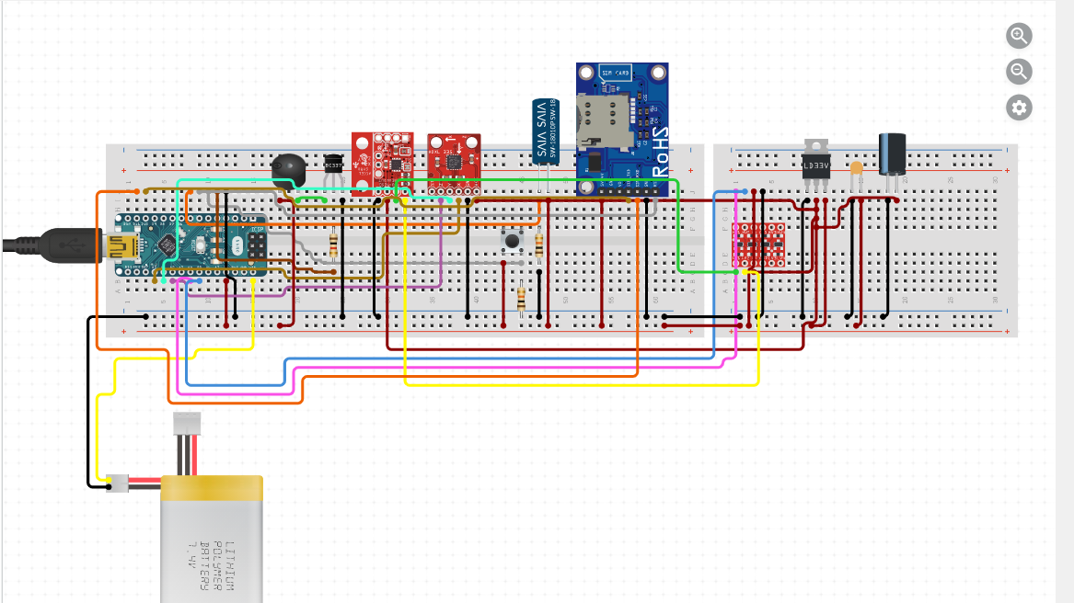

**3.1 Flow Chart of ______________**

In the given below flowchart ___________

**Figure 3.1 ___________________________**

* 1. **Detecting Result**
  2. **Software Required**

**3.3.1**

**3.3.2**

* 1. **Hardware Required**
     1. **Raspberry Pi**

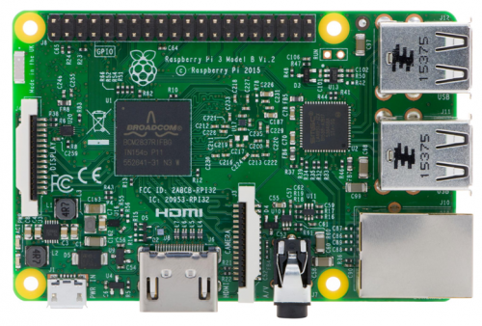

**Figure 3.1 ___________________________**

**Table 3.1 Specifications of ___________________________**

* + 1. **DC Motor**

**Figure 3.5 ___________________________**

**Table 3.2 Specifications of ___________________________**

* + 1. **L298 Motor Driver**

**Figure 3.6 ___________________________**

**Table 3.3 Specifications of ___________________________**

* + 1. **Camera**

**Figure 3.7 ___________________________**

**Table 3.4 Specifications of ___________________________**

**Chapter 4**

**Best Possible Design**

**4.1**

**Figure 4.1 ______________________**

**4.2**

**Figure 4.2 ___________________________**

**4.3**

**Figure 4.3 _____________________**

**Chapter 5**

**Simulation and Outcome**

**Code:**

**Output:**

**Chapter 6**

**Conclusion and Future Scope**

**6.1 Conclusion**

**6.2 Future Scope**

**References**

**1. Patent Number: __________________**

**Title** ___________________________

**Priority date** ___________________

**Inventor** ___________________

**2. Reseach Paper**

**Title** __________________________________

**Publication Year** ____________

**Author** ________________________________

**3.**

**4.**

**5.**

**6.**

**Cost Analysis**

|  |  |  |  |
| --- | --- | --- | --- |
| **S. No.** | **Component / Material** | | **Price (in Rs.)** |
| 1. |  | |  |
| 2. |  | |  |
| 3. |  | |  |
| 4. |  | |  |
| 5. |  | |  |
| 6. |  | |  |
| **Total** | |  | |

**ECE ARCHIVES PROJECT SUBMISSION FORM**

Project Code: **CU/ECE/20____/Sem____/UID______________ (To be filled by Office)**

Project Name: ________________________________________

Name and UID of student: _________________________________

Team Members:

|  |  |  |  |  |
| --- | --- | --- | --- | --- |
| **S. No.** | **Name** | **UID** | **Semester** | **Contact No.** |
| 1. |  |  |  |  |
| 2. |  |  |  |  |
| 3. |  |  |  |  |
| 4. |  |  |  |  |
| 5. |  |  |  |  |

**Section to be filled by Project Mentor**

**Status (Please tick, whichever applicable)**

|  |  |  |  |
| --- | --- | --- | --- |
| Working |  | Not Working |  |
| **Marks Awarded** | | **60** |  |

Project Mentor Details:

Name _______________________________ Employee ID _______________

Sign ________________________________ Date ______________________

**Section to be filled by Project Examiner(s)**

**Status (Please tick, whichever applicable)**

|  |  |  |  |
| --- | --- | --- | --- |
| Working |  | Not Working |  |

Project Examiner Signatures:

Internal _______________________________ Employee ID ______________

External _______________________________ Employee ID ______________

Date __________________________________